Name_redacted.com Monthly Analytics Report
For the period 2023-05-01 to 2023-09-30.
Report Generated: Mon Oct 16 15:14:32 2023.

Audience Overview

Users, Pageviews and Sessions
The table below shows the total number of users, sessions and pageviews grouped by month.
The average views per user and sessions per user for each month are also shown. Higher values indicate increased interaction with the site (views per user) and more willingness for users to return (sessions per user).
Month | Total Users | Views | Sessions | Views/User | Sessions/User
2023-05 | 42432 | 60125 | 52640 | 1.417 | 1.241
2023-06 | 36959 | 51173 | 45839 | 1.385 | 1.24
2023-07 | 34777 | 48066 | 43124 | 1.382 | 1.24
2023-08 | 38025 | 51964 | 47115 | 1.367 | 1.239
2023-09 | 42887 | 58319 | 52909 | 1.36 | 1.234
Average | 39016 | 53929 | 48325 | 1.382 | 1.239

- Users: A user is defined as a visitor who has logged at least one event on your website. As soon as a person lands on any page of your site they are either identified as a new or returning user based on their browser cookies.
- Views: A view of a page on your site that is being tracked in Google Analytics. If a user reloads the page after it is rendered then this is counted as an additional pageview. If a user navigates away from a page and then returns, this is also counted as an addional pageview.
- Sessions: A group of user interactions on your site that takes place within a given timeframe. Users that leave the site and return within 30 min are counted as a part of the original session.
The monthly variation in users, views and sessions over the period considered is plotted below. This illustrates the longer term traffic trends for the site.
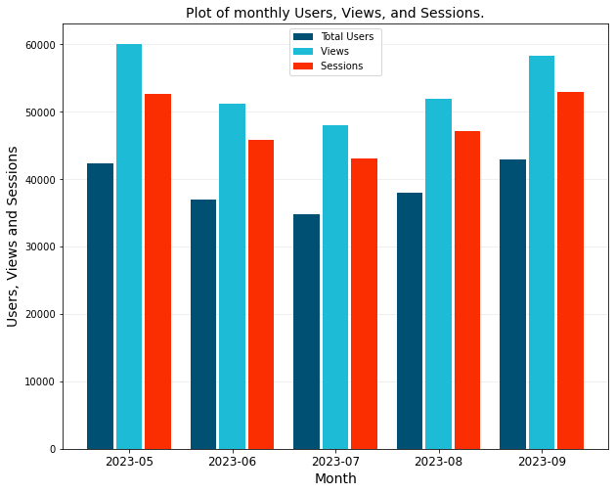
The monthly variation in pageviews per user and sessions per user shows the degree to which users are returning to, and interacting with the site. Larger values indicate increased interaction.
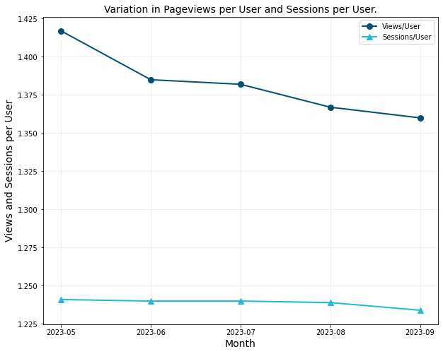

New and Returning Users
A user is identified as new when they interact with your site for the first time. Thereafter they are tagged as returning.
A returning user intiated at least one previous session, regardless of whether or not the session was an engaged session.
Month | Total Users | New Users | New Users (%) | Returning Users (%)
2023-05 | 42432 | 30106 | 70.95 | 29.05
2023-06 | 36959 | 26353 | 71.3 | 28.7
2023-07 | 34777 | 24556 | 70.61 | 29.39
2023-08 | 38025 | 26907 | 70.76 | 29.24
2023-09 | 42887 | 30662 | 71.49 | 28.51
Average | 39016 | 27716 | 71.04 | 28.96

The monthly percentage change in new and returning users is plotted in the figure below.
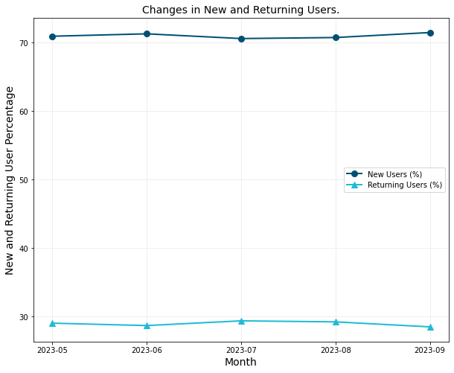

Active Users
An active user is defined as a user that visited your site.
The table below shows the number of active users across a daily, weekly and monthly period. For example, 28 day active users are the number of active users who visited your site within a 28 day period.
The values in the table are reported by month (rows). Therefore the average daily, weekly, and monthly users across the monthly period are tabulated.
Month | Mean 1-day Active Users | Mean 7-day Active Users | Mean 28-day Active Users | DAU / MAU (%) | DAU / WAU (%) | WAU / MAU (%)
2023-05 | 1166 | 7716 | 30992 | 3.5 | 15.11 | 23.19
2023-06 | 1042 | 6904 | 26530 | 3.66 | 15.09 | 24.29
2023-07 | 945 | 6328 | 24725 | 3.57 | 14.94 | 23.93
2023-08 | 1037 | 6575 | 24605 | 3.93 | 15.75 | 24.98
2023-09 | 1222 | 8046 | 28532 | 4.02 | 15.17 | 26.54

The ratio of Daily Active Users (DAU) to Monthly Active Users (MAU), Daily Active Users to Weekly Active Users (WAU), and Weekly Active Users to Montlhy Active Users are also tabulated.
This is a measure of User Stickiness as it compares user engagement over a narrower (DAU/WAU) and broader (DAU/MAU) timeframe.
These ratios can assist in understanding how well you retain users over time. Higher ratios across the board indicates better engagement and user retention.
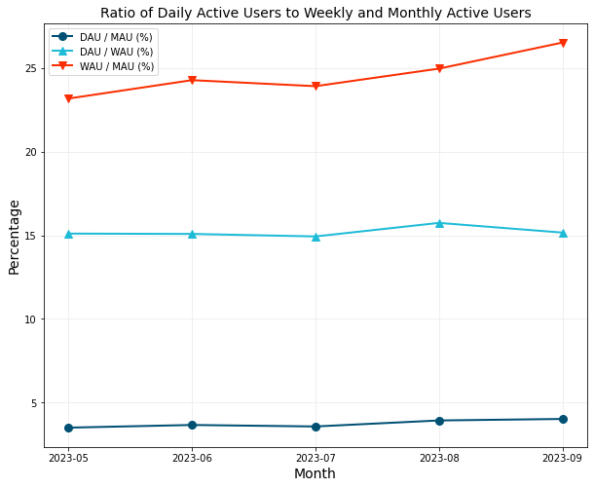

Change in Users, Pageviews and Sessions
The table below shows the monthly change in users, sessions, and pageviews expressed as a percentage of the previous month's numbers.
The cumulative change in views over the tabulated period is also shown. This is the per period change in views from the value given in the first row.
Month | Total Users | Views | Sessions | Users Change (%) | Sessions Change (%) | Views Change (%) | Cum. Views Change (%)
2023-05 | 42432 | 60125 | 52640 | - | - | - | -
2023-06 | 36959 | 51173 | 45839 | -12.9 | -12.92 | -14.89 | -14.89
2023-07 | 34777 | 48066 | 43124 | -5.9 | -5.92 | -6.07 | -20.06
2023-08 | 38025 | 51964 | 47115 | 9.34 | 9.25 | 8.11 | -13.57
2023-09 | 42887 | 58319 | 52909 | 12.79 | 12.3 | 12.23 | -3.0

The figure below graphically illustrates these changes on a per-period basis.
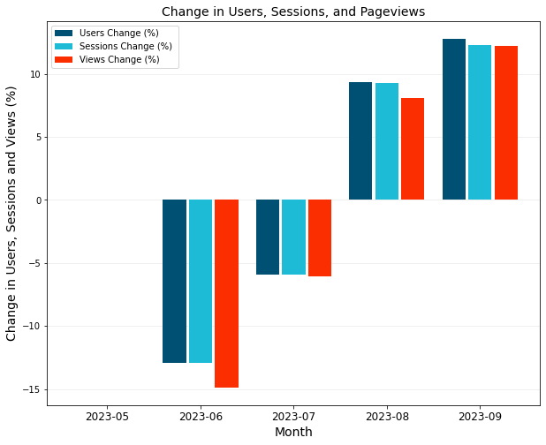

Session Engagement
Engagement rate and bounce rate are important metrics that enable you to measure and analyse user engagement.
Both metrics are defined in terms of engaged sessions.
- A session is a period during which a user is engaged with your website.
- An engaged session is a session that lasts more than 10 seconds, has a conversion event, or at least 2 pageviews.
- Every session is classified as either engaged or bounced.
- A bounced session is a session that is not engaged.
The table below shows the total sessions over the period, and the breakdown of engaged versus bounced sessions.
Month | Sessions | Engaged Sessions | Bounced Sessions | Engaged Sessions (%) | Bounced Sessions (%)
2023-05 | 52640 | 24370 | 28270 | 46.3 | 53.7
2023-06 | 45839 | 20820 | 25019 | 45.4 | 54.6
2023-07 | 43124 | 19663 | 23461 | 45.6 | 54.4
2023-08 | 47115 | 21596 | 25519 | 45.8 | 54.2
2023-09 | 52909 | 24417 | 28492 | 46.1 | 53.9

The figure below plots the absolute variation in monthly engaged sessions and bounces.
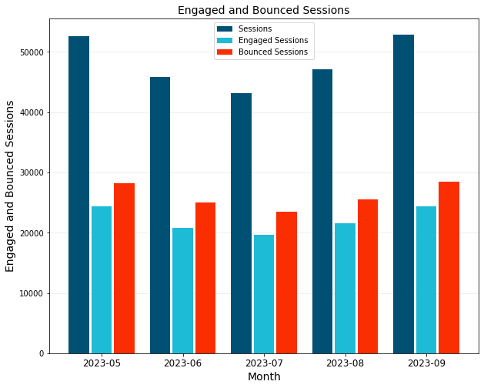
The monthly percentage variation in engaged and bounced sessions is plotted below. Ideally the rate of engaged sessions should be increasing over time with a corresponding decrease in bounced sessions.
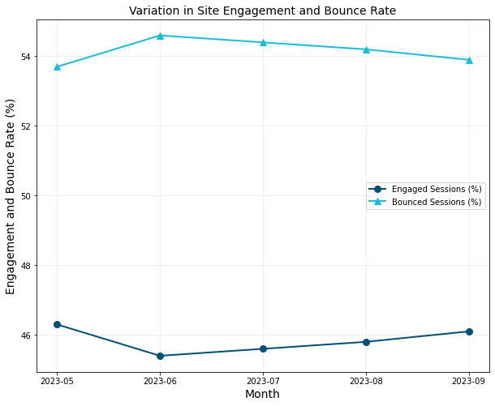

Site Time and Session Duration

Cumulative Site Time
The cumulative monthly site time is defined as the total amount of time spent on the website by all users over the month.
Site time is accumulated from the moment a user begins a new session till any one of the following happens:
- The user focuses away from the web page.
- The user closes the webpage tab or navigates to another screen or tab.
- The site crashes.
The average daily site time is calculated by dividing the total cumulative site time by the number of days across the period being considered.
Month | Sessions | Engaged Sessions | Cumulative Site Time | Ave Daily Site Time
2023-05 | 52640 | 24370 | 670 hr 32 min | 21 hr 38 min
2023-06 | 45839 | 20820 | 569 hr 12 min | 18 hr 58 min
2023-07 | 43124 | 19663 | 551 hr 03 min | 17 hr 47 min
2023-08 | 47115 | 21596 | 578 hr 52 min | 18 hr 40 min
2023-09 | 52909 | 24417 | 641 hr 56 min | 21 hr 24 min

The monthly variation in the daily average total active site time is plotted in the figure below.
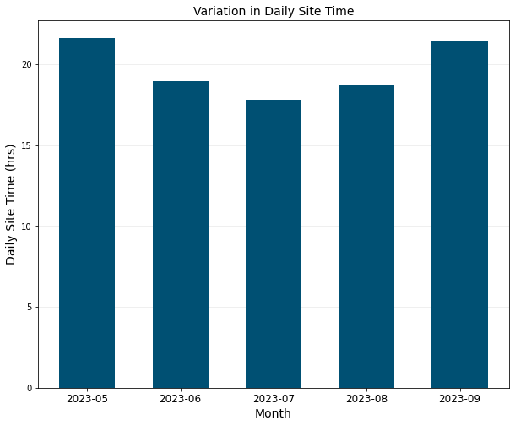

Average Session Duration
The average session duration is calculated by dividing the cumulative site time by the number of sessions in the period considered. This includes both engaged and bounced sessions.
The average engaged session duration removes the bounced sessions from the session duration calculation and only considers the engaged sessions.
Month | Sessions | Engaged Sessions | Ave Session Duration (mm:ss) | Ave Engaged Session Duration (mm:ss)
2023-05 | 52640 | 24370 | 00:46 | 01:39
2023-06 | 45839 | 20820 | 00:45 | 01:38
2023-07 | 43124 | 19663 | 00:46 | 01:41
2023-08 | 47115 | 21596 | 00:44 | 01:36
2023-09 | 52909 | 24417 | 00:44 | 01:35

The monthly variation in the average session duration (total session and engaged sessions) is plotted in the figure below.
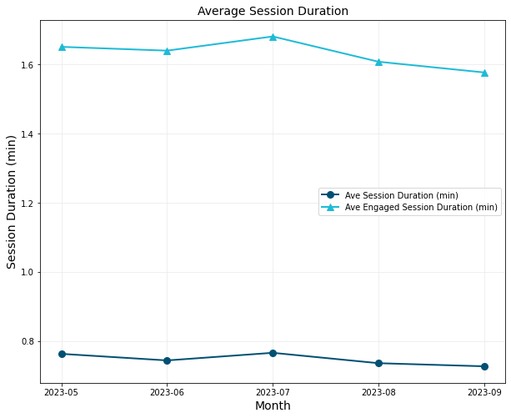

Traffic Sources

Traffic Breakdown by Sessions
Google Analytics automatically classifies the source of traffic to your site. The list below highlights some of the more common traffic source types often seen.
- Organic Search: Users arrive at your site via non-ad links accessed through a search engine.
- Direct: Users arrive at your site by directly entering your url.
- Referral: A referral link is a non-ad link to your site from another site (blogs, news sites, etc).
- Organic Social: This is a non-ad link on a social network like Facebook or X (Twitter).
- Organic Video: A non-ad link from a video site like Youtube, TikTok, or Vimeo.
- Paid Social, Paid Video, Paid Search: Users arrive on your site via a paid ad.
The table below shows the monthly traffic acquisition for the site by number of sessions.
Month | Organic Search | Direct | Referral | Organic Social | Unassigned | Organic Video | Total
2023-05 | 45882 | 6033 | 425 | 204 | 95 | 3 | 52642
2023-06 | 39529 | 5828 | 317 | 65 | 84 | 3 | 45826
2023-07 | 37456 | 5356 | 197 | 42 | 69 | 4 | 43124
2023-08 | 40392 | 6065 | 498 | 103 | 53 | 2 | 47113
2023-09 | 45929 | 6281 | 504 | 120 | 55 | 4 | 52893

The traffic breakdown for the month 2023-09 is shown as a percentage of total traffic in the table and pie chart below.
Traffic Source | Sessions | Percentage
Organic Search | 45929 | 86.83
Direct | 6281 | 11.87
Referral | 504 | 0.95
Organic Social | 120 | 0.23
Unassigned | 55 | 0.1
Organic Video | 4 | 0.01

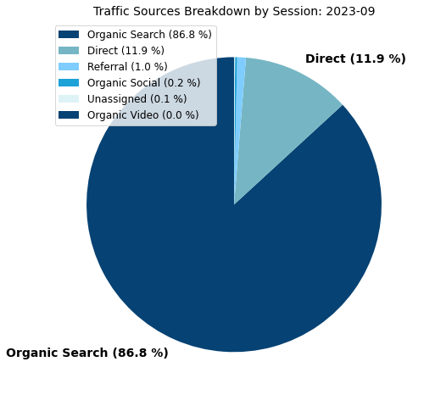

Traffic Breakdown by Users
The breakdown in traffic by users is shown in the table below.
Month | Organic Search | Direct | Referral | Organic Social | Unassigned | Organic Video | Total
2023-05 | 37248 | 4709 | 331 | 153 | 91 | 3 | 42535
2023-06 | 32180 | 4529 | 237 | 48 | 84 | 3 | 37081
2023-07 | 30360 | 4239 | 160 | 39 | 68 | 3 | 34869
2023-08 | 32869 | 4693 | 420 | 79 | 53 | 2 | 38116
2023-09 | 37456 | 5054 | 410 | 93 | 54 | 2 | 43069

The traffic breakdown for the month 2023-09 is shown as a percentage of total traffic in the table and pie chart below.
Traffic Source | Users | Percentage
Organic Search | 37456 | 86.97
Direct | 5054 | 11.73
Referral | 410 | 0.95
Organic Social | 93 | 0.22
Unassigned | 54 | 0.13
Organic Video | 2 | 0.0

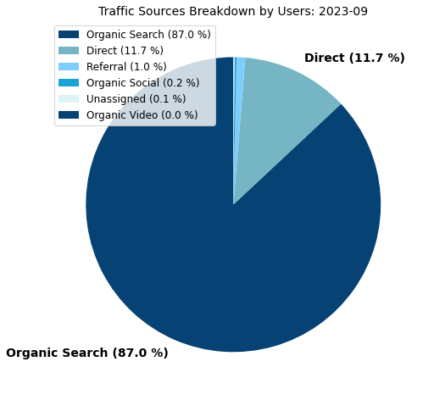

Site Content
This section of the report details the most popular pages on the website as well as the monthly variation in number of views of the top pages.
This report covers the period 2023-05-01 to 2023-09-30 which is 152 days.

Most Visited Pages
The table below gives a list of the top pages by view count for the period 2023-05-01 to 2023-09-30 (152 days).
The cumulative pageview count is also shown. This indicates the relative distribution of views across pages on the site.
The average time spent on the top pages provides some indication the quality of the page. Pages with large view counts and long view durations should be interpreted as pages of a high quality.
Rank | Page Path | Total Pageviews | Ave Daily Views | Percentage of Total Views (%) | Cum. Pageviews (%) | Ave Time on Page (min:sec)
1 | /crosswind/ | 66745 | 439 | 24.8 | 24.8 | 01:47
2 | /airspeed-conversions/ | 48791 | 321 | 18.1 | 42.8 | 02:44
3 | /atmcalc/ | 15278 | 101 | 5.7 | 48.5 | 02:32
4 | /lift-drag-moment-coefficient/ | 7687 | 51 | 2.9 | 51.4 | 02:60
5 | /intro-wing-design/ | 7458 | 49 | 2.8 | 54.1 | 03:06
6 | /wing-structural-design/ | 6977 | 46 | 2.6 | 56.7 | 02:47
7 | /density-altitude/ | 6173 | 41 | 2.3 | 59.0 | 02:22
8 | /naca-4-series-airfoil-generator/ | 5887 | 39 | 2.2 | 61.2 | 02:47
9 | /design-aircraft-tail/ | 5805 | 38 | 2.2 | 63.3 | 02:60
10 | /propeller/ | 5571 | 37 | 2.1 | 65.4 | 02:44
11 | /thrust-cruise-speed/ | 5566 | 37 | 2.1 | 67.5 | 02:52
12 | / | 4486 | 30 | 1.7 | 69.1 | 01:07
13 | /intro-fuselage-design/ | 3606 | 24 | 1.3 | 70.5 | 03:02
14 | /fuselage-structure/ | 3324 | 22 | 1.2 | 71.7 | 02:46
15 | /carburetor/ | 3154 | 21 | 1.2 | 72.9 | 02:58
16 | /aircraft-electrical-system/ | 3101 | 20 | 1.2 | 74.0 | 03:07
17 | /intro-sweep-angle/ | 3072 | 20 | 1.1 | 75.2 | 03:11
18 | /drag-polar/ | 2874 | 19 | 1.1 | 76.2 | 02:59
19 | /intro-airfoil-aerodynamics/ | 2870 | 19 | 1.1 | 77.3 | 02:31
20 | /metar/ | 2713 | 18 | 1.0 | 78.3 | 01:45
21 | /category/calculators/ | 2662 | 18 | 1.0 | 79.3 | 01:19
22 | /wing-structure/ | 2524 | 17 | 0.9 | 80.2 | 02:53
23 | All other pages | 53323 | 351 | 19.8 | 100 | -

Top Pages Views Breakdown
The percentage breakdown of views across the top pages is shown in the figure below.
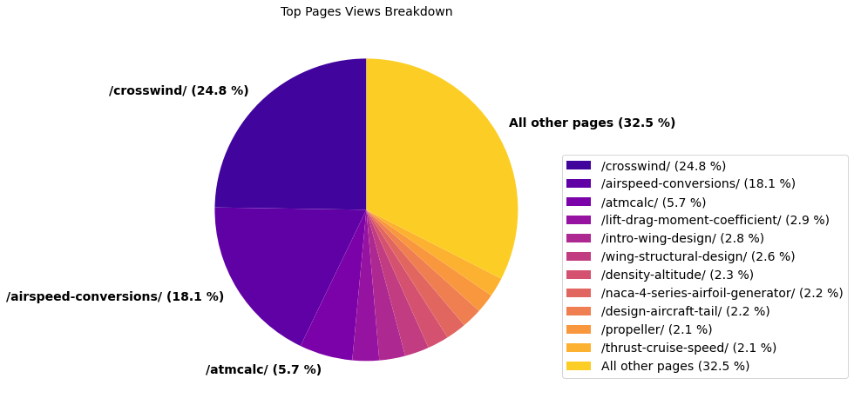

Top Pages by Users and Sessions
The table below shows the total users, sessions and pageviews for the top pages for the period 2023-05-01 to 2023-09-30 (152 days).
The pageview-per-user metric gives an indication of how likely a user is to return to that page.
Rank | Page Path | Users | Sessions | Pageviews | Pageviews per User
1 | /crosswind/ | 35575 | 67104 | 66745 | 1.88
2 | /airspeed-conversions/ | 29591 | 49405 | 48791 | 1.65
3 | /atmcalc/ | 9500 | 16229 | 15278 | 1.61
4 | /lift-drag-moment-coefficient/ | 5308 | 8263 | 7687 | 1.45
5 | /intro-wing-design/ | 5253 | 7538 | 7458 | 1.42
6 | /wing-structural-design/ | 4679 | 7158 | 6977 | 1.49
7 | /density-altitude/ | 4545 | 5923 | 6173 | 1.36
8 | /naca-4-series-airfoil-generator/ | 3486 | 5280 | 5887 | 1.69
9 | /design-aircraft-tail/ | 3802 | 5850 | 5805 | 1.53
10 | /propeller/ | 3986 | 5777 | 5571 | 1.4
11 | /thrust-cruise-speed/ | 3774 | 5735 | 5566 | 1.47
12 | / | 2838 | 3811 | 4486 | 1.58
13 | /intro-fuselage-design/ | 2737 | 3573 | 3606 | 1.32
14 | /fuselage-structure/ | 2538 | 3176 | 3324 | 1.31
15 | /carburetor/ | 2222 | 3055 | 3154 | 1.42
16 | /aircraft-electrical-system/ | 2160 | 2996 | 3101 | 1.44
17 | /intro-sweep-angle/ | 2246 | 3170 | 3072 | 1.37
18 | /drag-polar/ | 1920 | 2918 | 2874 | 1.5
19 | /intro-airfoil-aerodynamics/ | 2074 | 3007 | 2870 | 1.38
20 | /metar/ | 1171 | 1520 | 2713 | 2.32
21 | /category/calculators/ | 1487 | 1778 | 2662 | 1.79
22 | /wing-structure/ | 1869 | 2526 | 2524 | 1.35
23 | All other pages | 38344 | 50280 | 53323 | 1.39

The number of pageviews-per-user across the top pages is plotted in the figure below. The plot is ordered in terms of popularity (view count) from left to right.
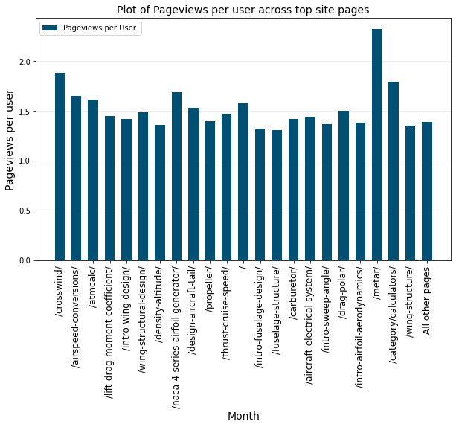

Monthly Pageview Variation in Top Pages
The monthly variation in pageviews across the top site pages is shown in the table below.
The pageview variation shown in the table are plotted in the below figure where view trends become clearer to discern.
Month | /crosswind/ | /airspeed-conversions/ | /atmcalc/ | /intro-wing-design/ | /lift-drag-moment-coefficient/ | /naca-4-series-airfoil-generator/ | /wing-structural-design/ | /density-altitude/
2023-05 | 13584 | 10097 | 3026 | 1635 | 2123 | 1480 | 1960 | 1074
2023-06 | 12614 | 9749 | 2810 | 1409 | 1339 | 1005 | 1293 | 1085
2023-07 | 12462 | 9142 | 2558 | 1200 | 1211 | 919 | 1098 | 1406
2023-08 | 13873 | 9713 | 3153 | 1330 | 1198 | 893 | 1211 | 1317
2023-09 | 14212 | 10090 | 3731 | 1884 | 1816 | 1590 | 1415 | 1291

The below figure plots the variation in pageviews across the top pages by month.

User Demographics
User demographics provide a deeper insight into who the users of your site are, when the site is most accessed, and on what devices pages are viewed.

Users and Pageviews by Country
The table below shows the breakdown of site users and views by country for the period 2023-05-01 to 2023-09-30 (152 days).
Users and views are shown as a percentage of the total users/views across the site. The cumulative pageviews column allows you to quickly determine the percentage of total views coming from the highest traffic countries.
Rank | Country | Users | Total Users (%) | Pageviews | Ave Daily Views | Total Views (%) | Cumulative Views (%) | Pageviews per User
1 | United States | 60414 | 42.1 | 109757 | 722 | 40.7 | 40.7 | 1.82
2 | India | 9799 | 6.8 | 19308 | 127 | 7.2 | 47.86 | 1.97
3 | United Kingdom | 8954 | 6.2 | 16832 | 110 | 6.2 | 54.11 | 1.88
4 | Australia | 5858 | 4.1 | 10581 | 69 | 3.9 | 58.03 | 1.81
5 | Canada | 5290 | 3.7 | 9170 | 60 | 3.4 | 61.43 | 1.73
6 | Philippines | 3744 | 2.6 | 7027 | 46 | 2.6 | 64.04 | 1.88
7 | Germany | 3101 | 2.2 | 5989 | 39 | 2.2 | 66.26 | 1.93
8 | Türkiye | 2850 | 2.0 | 5752 | 37 | 2.1 | 68.39 | 2.02
9 | France | 2175 | 1.5 | 3994 | 26 | 1.5 | 69.87 | 1.84
10 | Spain | 2155 | 1.5 | 3983 | 26 | 1.5 | 71.35 | 1.85
11 | Netherlands | 2134 | 1.5 | 3921 | 25 | 1.5 | 72.8 | 1.84
12 | Italy | 1986 | 1.4 | 3764 | 24 | 1.4 | 74.2 | 1.9
13 | South Korea | 1684 | 1.2 | 3314 | 21 | 1.2 | 75.43 | 1.97
14 | South Africa | 1176 | 0.8 | 3308 | 21 | 1.2 | 76.66 | 2.81
15 | Brazil | 1392 | 1.0 | 3175 | 20 | 1.2 | 77.83 | 2.28
16 | Indonesia | 1401 | 1.0 | 2589 | 17 | 1.0 | 78.79 | 1.85
17 | China | 1442 | 1.0 | 2461 | 16 | 0.9 | 79.71 | 1.71
18 | Iran | 883 | 0.6 | 1925 | 12 | 0.7 | 80.42 | 2.18
19 | All Other Countries | 27056 | 18.8 | 52797 | 347 | 19.6 | 100 | 1.95

The breakdown of site users by country is shown in the pie chart below.
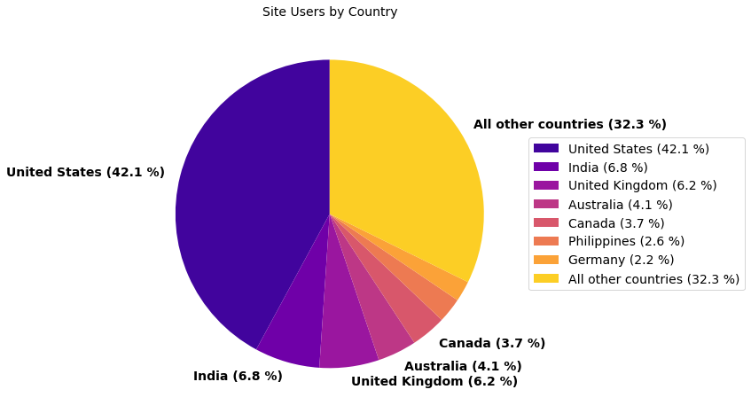
The average pageviews-per-user by country is shown in the figure below.
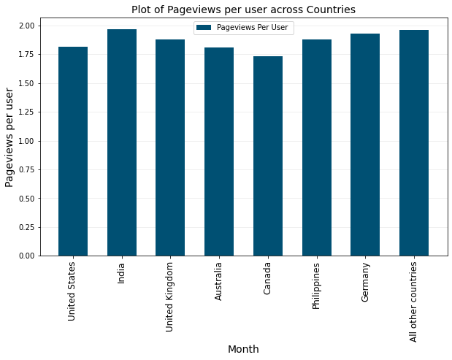

Session Engagement by Country
Engagement rate and bounce rate are important metrics that enable you to measure and analyse user engagement.
Both metrics are defined in terms of engaged sessions.
- A session is a period during which a user is engaged with your website.
- An engaged session is a session that lasts more than 10 seconds, has a conversion event, or at least 2 pageviews.
- Every session is classified as either engaged or bounced.
- A bounced session is a session that is not engaged.
The table below shows the total sessions by country over the period, and the breakdown of engaged versus bounced sessions.
Rank | Country | Sessions | Engaged Sessions | Engaged Sessions (%) | Bounced Sessions (%) | Ave Engaged Session Duration
1 | United States | 98715 | 42519 | 43.07 | 56.93 | 01:27
2 | India | 15569 | 7928 | 50.92 | 49.08 | 02:19
3 | United Kingdom | 14865 | 7446 | 50.09 | 49.91 | 01:39
4 | Australia | 9818 | 4738 | 48.26 | 51.74 | 01:39
5 | Canada | 8365 | 4257 | 50.89 | 49.11 | 01:36
6 | Philippines | 6112 | 2681 | 43.86 | 56.14 | 01:32
7 | Germany | 5475 | 2750 | 50.23 | 49.77 | 01:27
8 | Türkiye | 5171 | 2408 | 46.57 | 53.43 | 01:24
9 | France | 3592 | 1953 | 54.37 | 45.63 | 01:29
10 | Spain | 3810 | 1977 | 51.89 | 48.11 | 01:24

The bar chart below shows the relative session engagement from the countries with the greatest number of sessions.
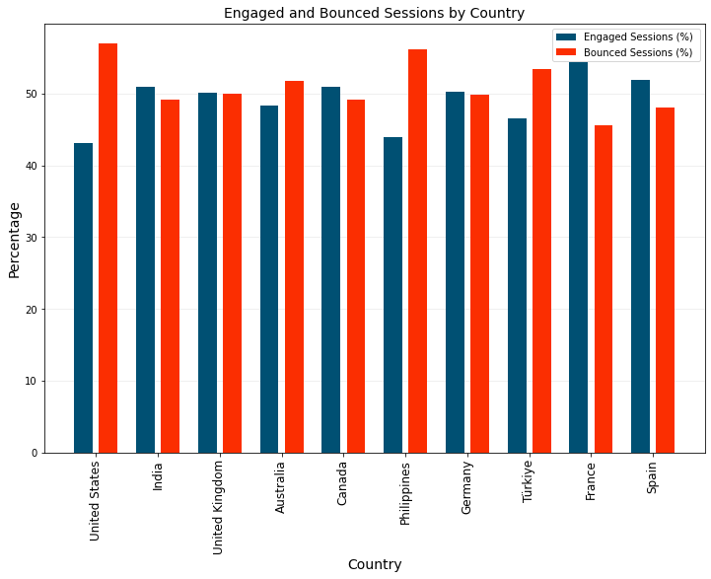
The average engaged session duration (in seconds) from the countries with the greatest number of sessions is plotted below. Ideally the countries with the most users should see higher engagement rates and durations than the countries with fewer users.
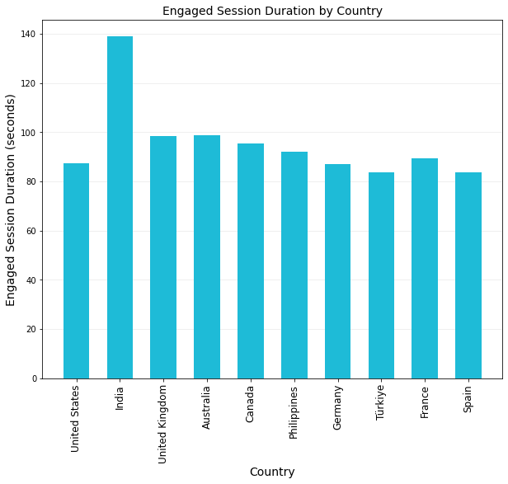

Change in Users by Country
The monthly variation in user numbers by country are tabled below for the countries with the most users.
Month | Total | United States | India | United Kingdom | Australia | Canada | Philippines | Netherlands | Germany | Spain | Türkiye
2023-05 | 42563 | 17102 | 2521 | 3365 | 1543 | 1430 | 1059 | 598 | 915 | 771 | 984
2023-06 | 37077 | 16043 | 2362 | 2210 | 1269 | 1306 | 585 | 573 | 991 | 562 | 743
2023-07 | 34898 | 15024 | 2249 | 2272 | 1165 | 1270 | 600 | 412 | 883 | 489 | 753
2023-08 | 38143 | 16690 | 2743 | 2091 | 2180 | 1213 | 1084 | 424 | 820 | 445 | 815
2023-09 | 42984 | 18705 | 2964 | 2167 | 2029 | 1761 | 1443 | 934 | 779 | 720 | 688

The variation in monthly user numbers per country is shown in the figure below.

Device Category Breakdown
The breakdown in type of device used to view the site is shown in the table below.
The most common device categories are:
- Desktop
- Mobile
- Tablet
The data used to generate the table is for the period 2023-05-01 to 2023-09-30 (152 days).
Device Category | Total Users | Sessions | Views | % Users | % Views
desktop | 84234 | 149687 | 163083 | 59.1 | 60.5
mobile | 54365 | 87596 | 98827 | 38.1 | 36.7
tablet | 3997 | 6596 | 7724 | 2.8 | 2.9
smart tv | 8 | 13 | 13 | 0.0 | 0.0
Total | 142604 | 243892 | 269647 | 100 | 100

The pie chart below shows the relative contribution of the various device categories by pageviews.
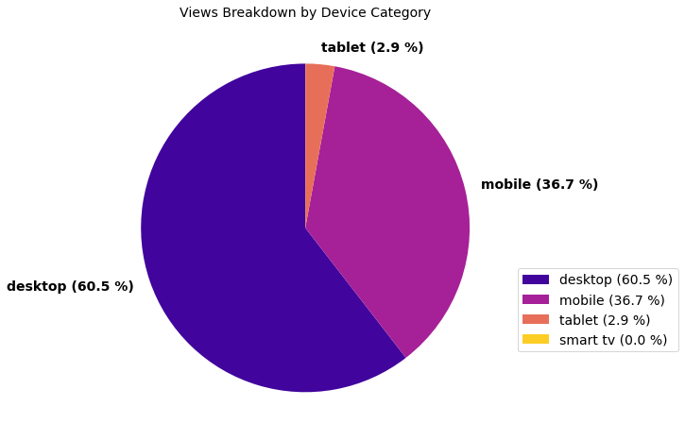

Site Visits by Day of Week
The table below summarises the relative breakdown of users, sessions, and views by day of the week.
The data used to generate the table is extracted for the period 2023-05-01 to 2023-09-30 (152 days).
Day of the Week | % Users | % Sessions | % Views
Wednesday | 16.6 | 17.0 | 16.8
Tuesday | 16.7 | 16.5 | 16.7
Thursday | 16.1 | 16.1 | 16.1
Monday | 15.4 | 15.4 | 15.2
Friday | 14.5 | 14.4 | 14.4
Saturday | 10.7 | 10.5 | 10.7
Sunday | 10.0 | 10.0 | 10.2

The breakdown of total site visits by day of the week is shown in the pie chart below.
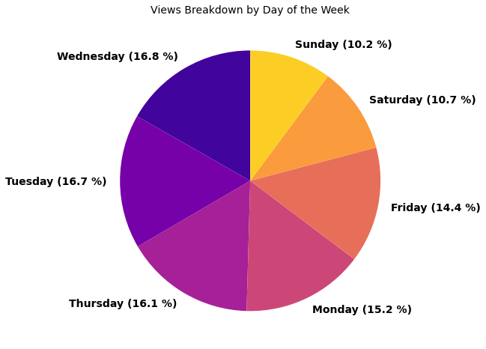

Google Search Console
Google analytics allows for integration with Google Search Console to provide organic search related insights to your site.

Search Performance by Month
The table below shows the average monthly search ranking across all search terms that yielded an impression on Google. Lower search positions are better as they
indicate that the site pages are closer to the top of Google's search ranking.
The number of monthly impressions and clicks are also tabulated as well as the click through rate which is the ratio of clicks-to-impressions.
The data used to generate the table is extracted for the period 2023-05-01 to 2023-09-30 (152 days).
Month | Average Search Position | Number of Impressions | Number of Clicks | Click Through Rate (%)
2023-05 | 12.043 | 1023442 | 28888 | 2.81
2023-06 | 12.957 | 896906 | 24825 | 2.76
2023-07 | 13.196 | 846616 | 23557 | 2.77
2023-08 | 12.045 | 891257 | 26050 | 2.92
2023-09 | 12.938 | 1146627 | 30052 | 2.64

The monthly variation in average search position and click-through-rate are plotted in the figures below.
- Average search position refers to the average ranking of all website URLs for the queries reported from Search Console.
- The click through rate is the percentage of impressions that result in a click.
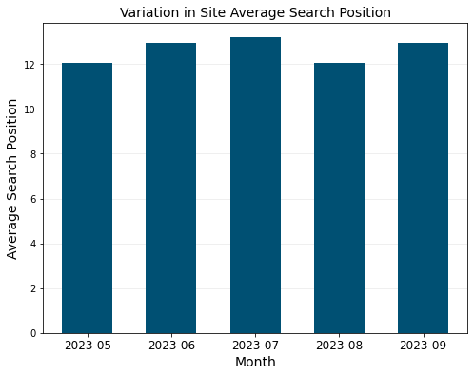
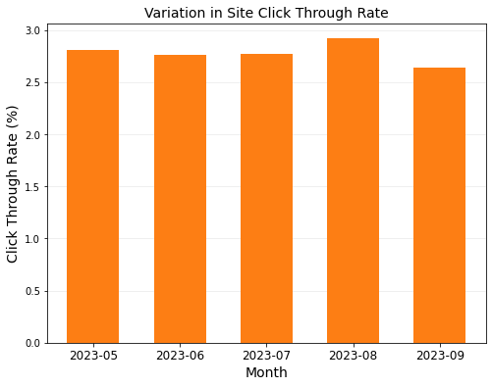
The monthly trend of search impressions and clicks across all queries reported in Search Console is shown in the figures below.
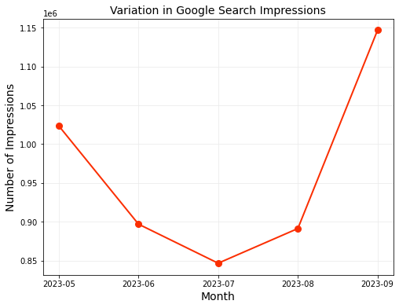
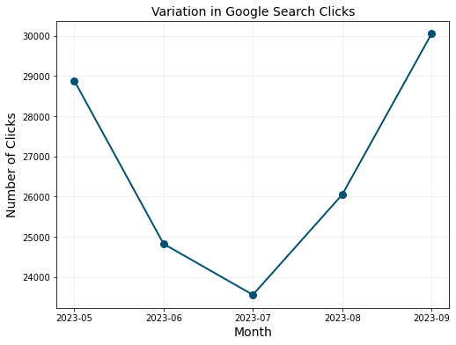

Search Performance by Page
The average search ranking for each of the 20 most popular pages is shown in the table below.
- Pages in the table are ranked by number of clicks in descending order.
- Pay close attention to the click-through-rate of the top pages. Pages with high view counts and high click through rates indicate high performing pages.
- Average search position per page is for all terms that yield a search impression. The page may rank highly for certain high-volume terms and lower for other low-volume terms which can reduce the overall search position.
The data used to generate the table is extracted for the period 2023-05-01 to 2023-09-30 (152 days).
Landing Page | Average Search Position | Number of Impressions | Number of Clicks | Click Through Rate (%) | Average Daily Impressions | Average Daily Clicks
/crosswind/ | 7.875 | 180820 | 36597 | 20.24 | 1190 | 241
/airspeed-conversions/ | 9.637 | 384054 | 30588 | 7.96 | 2527 | 201
/atmcalc/ | 16.073 | 137470 | 9769 | 7.11 | 904 | 64
/lift-drag-moment-coefficient/ | 12.163 | 228840 | 4292 | 1.88 | 1506 | 28
/thrust-cruise-speed/ | 11.963 | 201803 | 3279 | 1.62 | 1328 | 22
/intro-wing-design/ | 11.517 | 617793 | 3254 | 0.53 | 4064 | 21
/wing-structural-design/ | 9.24 | 277725 | 3187 | 1.15 | 1827 | 21
/design-aircraft-tail/ | 9.729 | 268921 | 3133 | 1.17 | 1769 | 21
/naca-4-series-airfoil-generator/ | 8.598 | 69001 | 2986 | 4.33 | 454 | 20
/propeller/ | 9.342 | 462291 | 2918 | 0.63 | 3041 | 19
/density-altitude/ | 10.934 | 144155 | 2383 | 1.65 | 948 | 16
/intro-fuselage-design/ | 9.246 | 106378 | 2198 | 2.07 | 700 | 14
/fuselage-structure/ | 6.279 | 176701 | 1666 | 0.94 | 1163 | 11
/carburetor/ | 10.693 | 267942 | 1654 | 0.62 | 1763 | 11
/intro-sweep-angle/ | 11.779 | 115731 | 1546 | 1.34 | 761 | 10
/reynolds-number-calculator/ | 14.872 | 52335 | 1456 | 2.78 | 344 | 10
/drag-polar/ | 10.194 | 102532 | 1432 | 1.4 | 675 | 9
/aircraft-electrical-system/ | 10.38 | 108783 | 1337 | 1.23 | 716 | 9
/aspect-ratio/ | 6.7 | 90442 | 1196 | 1.32 | 595 | 8
/hydraulic-system/ | 12.217 | 236366 | 1137 | 0.48 | 1555 | 7

The average daily impression and average daily number of clicks for the period 2023-05-01 to 2023-09-30 (152 days) are plotted on the same set of axes in the figure below.
- Pages with a high number of impressions but low daily clicks represent an opportunity to increase click through rate through Search Engine Optimisation.
- The ratio of clicks-to-impressions is defined as the click-through rate.
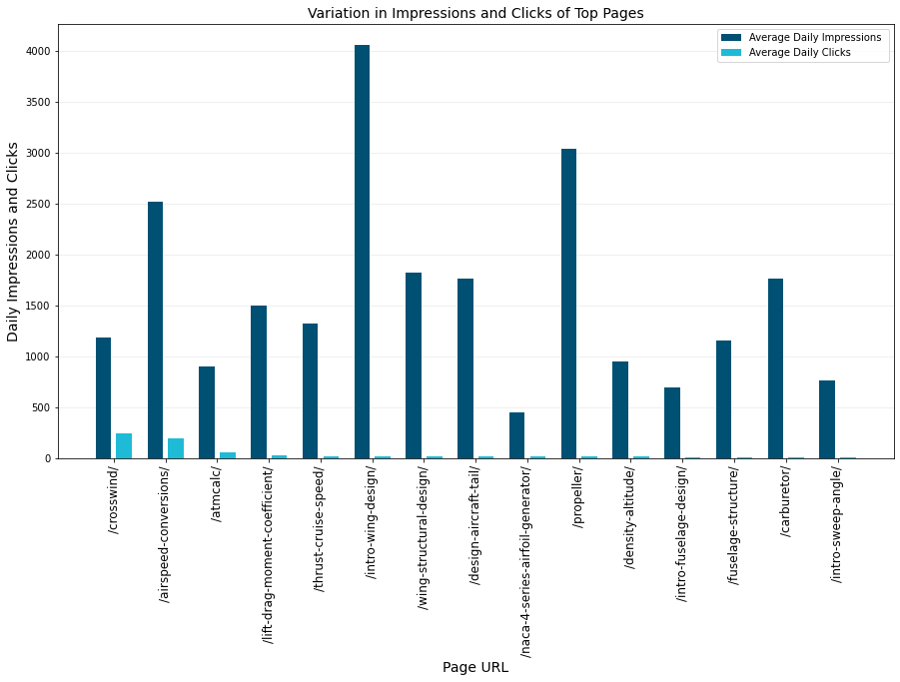
The variation in click through rate of the most traffic pages are plotted in the figure below.
